Justin Wisner
MUS 455
Dr. Robinson
January 16, 2018

Rote Song Treasure Hunt

Lyrics and notation:
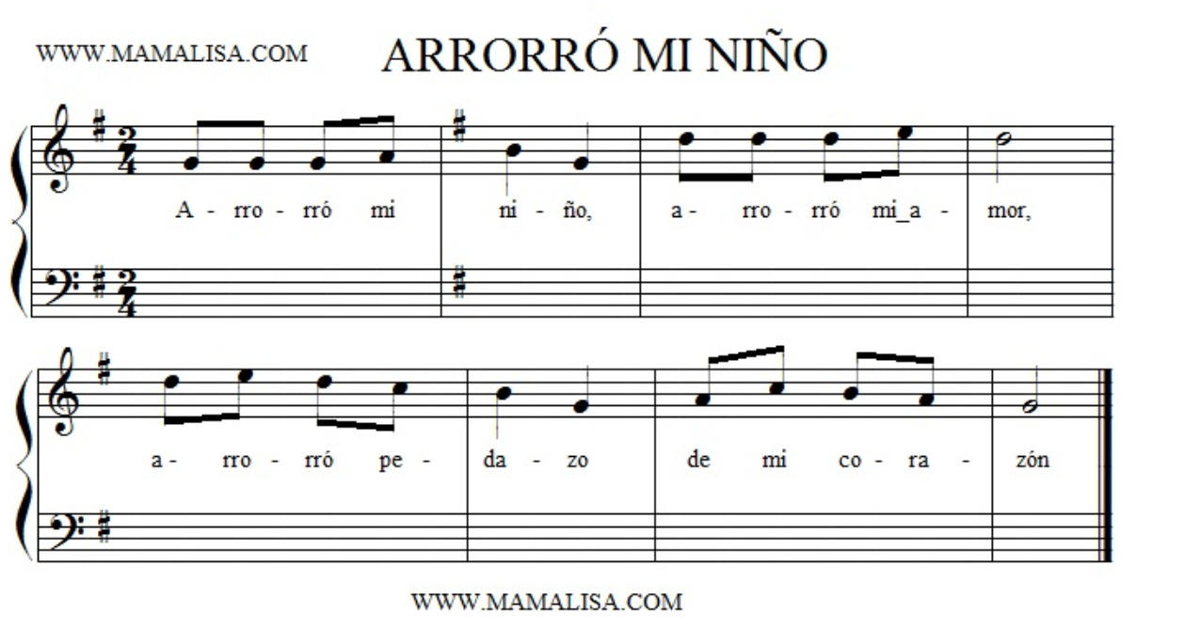
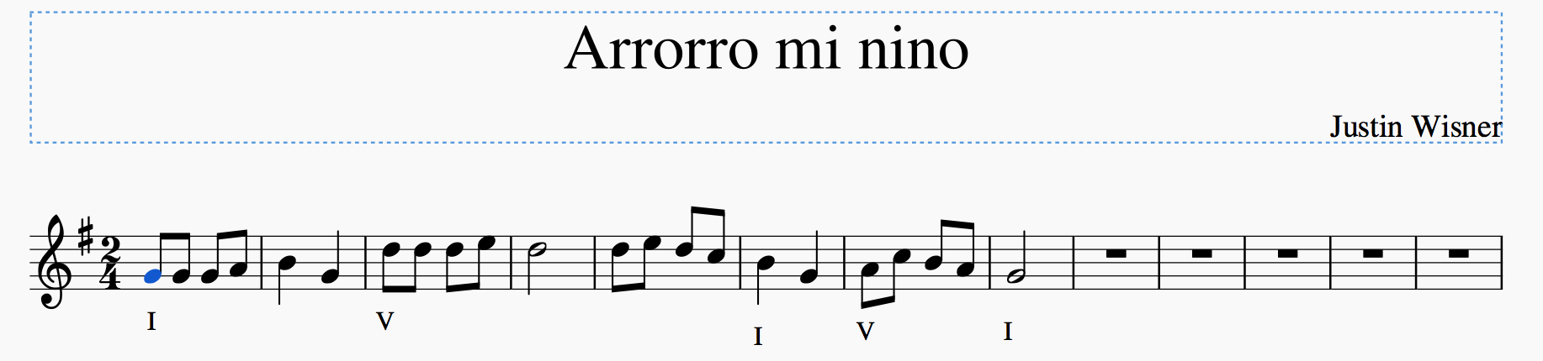
With harmonic changes:

With accompanying bass line:
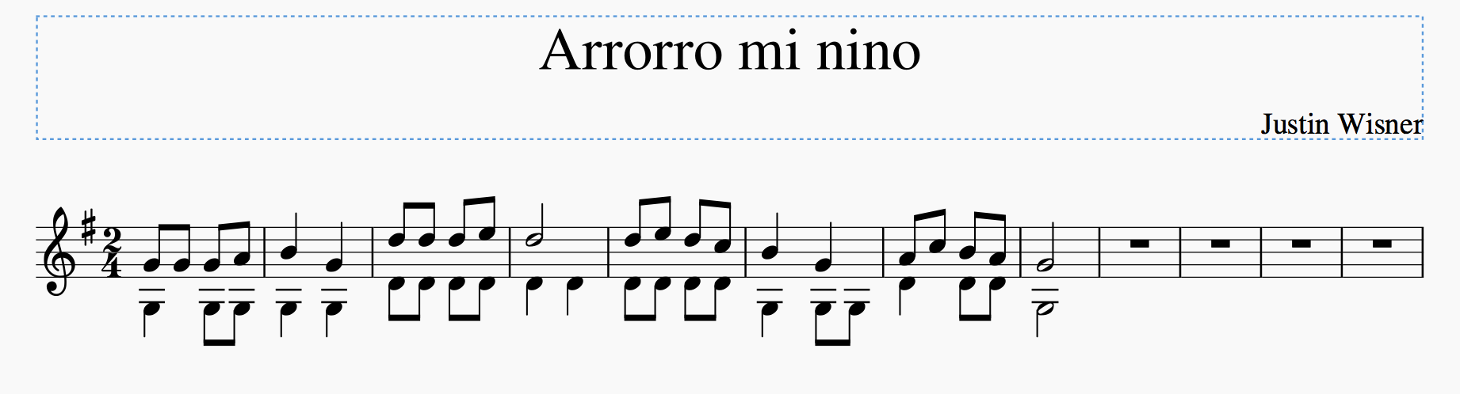
Background:
Arrorró mi niño is one of the most popular Mexican lullabies. It is to be sung to babies as they fall asleep. It is a song traditionally handed down from generation to generation. The title of the song can be translated in English to “Hush-a-bye My Child”.

