Kate Falck
Dr. Robinson
MUS 455
17 January 2018
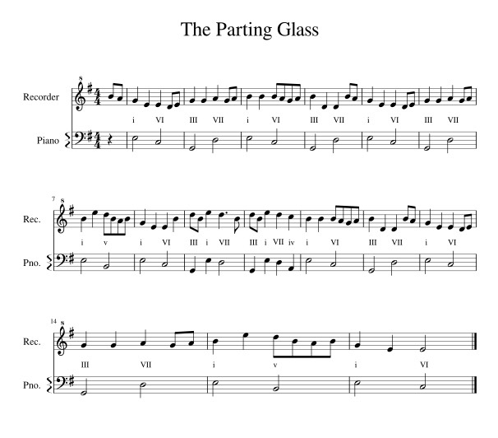
Lyrics (verses 1 and 2):

Oh all the money that e'er I spent
I spent it in good company
And all the harm that e'er I've done
Alas, it was to none but me
And all I've done for want of wit
To memory now I can't recall
So fill to me the parting glass
Good night and joy be with you all
Oh all the comrades that e'er I've had
Are sorry for my going away
And all the sweethearts that e'er I've had
Would wish me one more day to stay
But since it falls unto my lot
That I should rise and you should not
I'll gently rise and I'll softly call
Good night and joy be with you all

Harmonic Changes: included in score with the bassline

History:
This folk song was used as a parting song (a "goodbye" song) in both Ireland and Scotland often used in gatherings among friends. It is thought to have originated in the 1700's. I find it interesting that although the song talks of departure, the song sounds like it continues rather than finishes at the end. I think that this could be symbolic of the idea that we never truly say goodbye to good friends and family as we will always see them soon. The piece is interesting in tonality in that it is in aeolian mode (natural minor rather than harmonic minor) and does not have the harmonic changes expected in most Western music. Though this is the basic melody, every arrangement/ version which I listened to contained different variations of ornamentation throughout. This is characteristic of the improvisatory style of traditional Celtic music.

