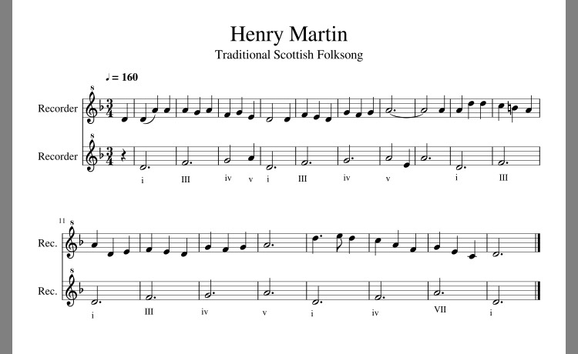

The folksong “Henry Martin” is tonally interesting because it is based on the Dorian scale and it originates from Scotland. “Henry Martin” tells the story of sailor Andrew Barton of Scotland. Barton had a letter of marque from King James IV of Scotland but he abused his power and turned to piracy to support himself and his two older brothers. The original ballad had 82 verses but over time, due to oral tradition, the song was significantly shortened and the name Andrew Barton was changed to Henry Martin.

Text:
There were- three brothers in merry Scotland,
In Scotland there liv’d brothers three;
And lots they did cast which should rob on the sea,- salt sea- salt sea.
“For to maintain my two brothers and me.”

