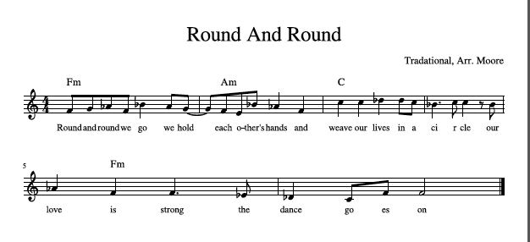
“Round and Round” is a traditional American folk song believed to come from communities in Massachusetts, possibly similar to Quakers or similar ostracized, religious groups. This song was used in courtship and there is an accompanying dance.

